MIC502 Fan Management IC Replacement Using ATtiny25 Application Note

Introduction
The purpose of this application note is to document the design and implementation of a microcontroller-based replacement solution for the MIC502 fan management IC. The MIC502 is an application-specific integrated circuit (ASIC) originally designed for thermal fan-speed control, low-frequency PWM fan driving, sleep-mode operation, startup timing, and overtemperature fault detection. However, because the original MIC502 device is no longer available for production sourcing, a replacement solution is required for continued support of the target fan management PCB.
This project uses the ATtiny25 AVR microcontroller to emulate the core behavior of the MIC502 while maintaining the replacement goals of function, form, and fit. From the functional perspective, the ATtiny25 firmware is designed to reproduce the MIC502 control behavior, including temperature-dependent PWM output, startup fan forcing, sleep-mode detection, shutdown behavior, and overtemperature fault logic. From the form and fit perspective, the replacement design is intended to operate within the electrical and physical constraints of the existing PCB so that the original fan management function can be preserved with minimal system-level modification.
This application note first explains the circuit-level design of the fan management system, including how the temperature sensing network generates the analog temperature input voltage, VT1, and how this voltage is used as the control input for fan-speed regulation. The report then introduces the embedded software implementation developed in AVR C using MPLAB X IDE, where the ATtiny25 samples the analog inputs through its internal ADC, processes the MIC502-equivalent control logic, and generates the PWM drive signal for the external fan driver stage. Together, the hardware and firmware demonstrate a practical replacement approach for migrating from a discontinued analog fan-management ASIC to a programmable microcontroller-based solution.

Hardware Architecture
Figure B-1 depicts the hardware functional block diagram. The fan management control board is designed as a modular replacement platform for the MIC502 fan management IC. The hardware is organized into several functional sections: the 24 V fan power path, the 5 V logic and sensing supply path, the thermistor-based analog sensing path, the user-controlled minimum fan-speed clamp, the MIC502 or ATtiny25 control core, and the MOSFET fan-drive output stage. This structure allows the same board concept to support either the original MIC502 device or an ATtiny25-based firmware replacement.
The 24 V input provides the main power source for the brushless DC fan. Before reaching the fan connectors, the input rail passes through protection and filtering components to reduce supply noise and protect the circuit from switching transients generated by the fan and MOSFET drive stage. The fan is driven through a low-side MOSFET switch, where the control core generates a PWM signal that modulates the fan current and therefore controls the effective fan speed.
A separate 5 V regulator generates the low-voltage rail used by the control and signal-processing circuitry. This 5 V rail powers the MIC502 or ATtiny25 control core, the op-amp signal-conditioning stage, the thermistor sensing network, the push-button interface, and the fault indicator circuitry. Local decoupling and filtering are included to stabilize the 5 V rail and reduce noise coupling into the analog temperature-sensing path.
The temperature input is produced by an external NTC thermistor connected through the sensor header. The thermistor voltage is processed by an analog signal-conditioning stage that includes a voltage divider, buffer, op-amp gain, and offset adjustment. This stage maps the thermistor’s temperature-dependent voltage into the VT1 control range used by the MIC502 or the ADC input range used by the ATtiny25 firmware. The purpose of this conditioning stage is to provide flexibility when selecting different thermistors and to scale the sensing voltage into a useful fan-control range.
The VT2 input is used as a user-selectable minimum fan-speed clamp. A push button enables or disables this clamp circuit, allowing the system either to maintain a minimum fan speed or to allow the output duty cycle to fully follow the VT1 temperature input. When enabled, the clamp prevents the fan from shutting completely off at low temperature, which avoids repeated fan restart events, reduces startup current stress, and helps maintain continuous low-speed airflow.
The control core receives the VT1 temperature-control signal and the VT2 minimum-speed clamp signal, then generates the PWM output for the MOSFET gate driver. It also provides an active-low overtemperature fault output, /OTF, which drives the red fault LED and can be routed to an external fault-monitoring point. In the ATtiny25 implementation, these MIC502 behaviors are reproduced in firmware, including PWM duty-cycle mapping, startup drive, overtemperature detection, minimum-speed clamp control, and power-off/reset behavior.

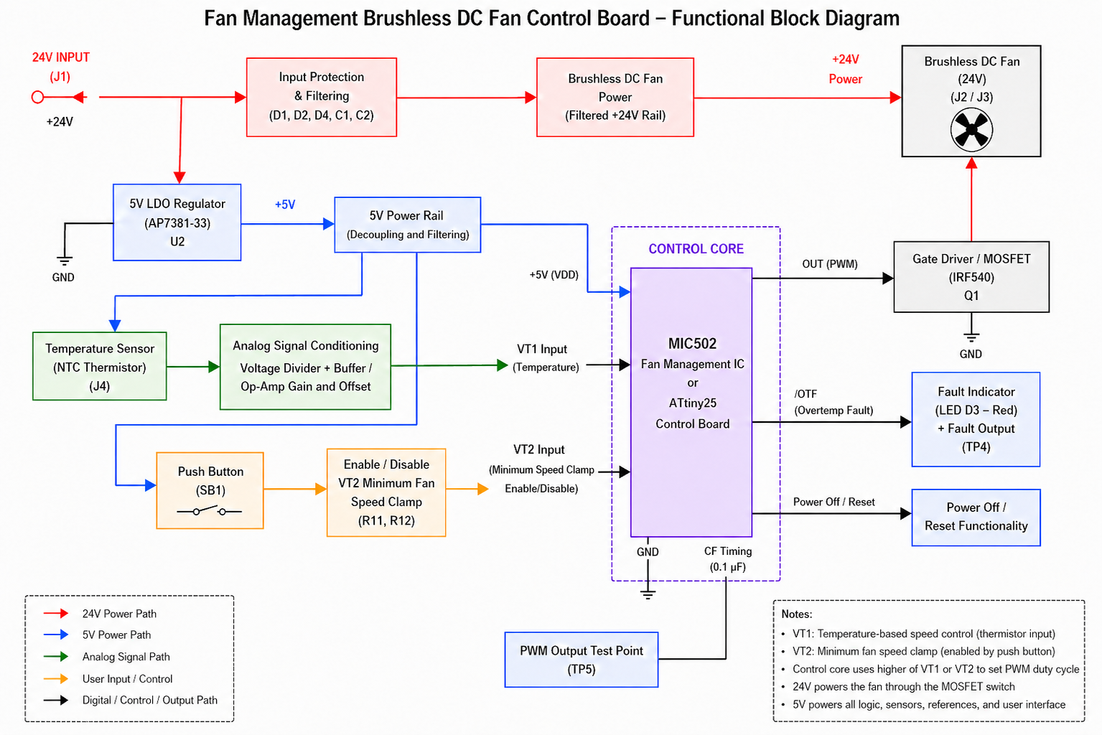

Figure 1. Hardware Functional Block Diagram

Theory of Circuitry Operation

Figure B-2 depicts this fan management circuit which converts a temperature-dependent analog voltage into a PWM fan-drive signal. The schematic uses U1 as the MIC502 fan management IC, U2 as the low-voltage regulator for the control electronics, U3A/U3B as the analog signal-conditioning stage, and Q1 as the external low-side MOSFET driver for the fan. The circuit receives a +24 V input supply through connector J1. This +24 V rail is used directly as the fan supply. The same +24 V input is also fed into regulator U2, which generates the low-voltage logic/control rail labeled +5 V in the schematic. Capacitors C1 and C2 provide input filtering for the regulator, while C3 provides output decoupling on the +5 V rail. The schematic uses a Vishay NTCLE100E3103HB0 NTC thermistor connected with R7 to form a temperature-dependent voltage divider. The NTC is connected to the +5 V rail, and R7 is connected from the sensing node to ground. C8 µF is connected from the sensing node to ground, so it filters the raw thermistor voltage before the signal enters the op-amp stage. The schematic shows this raw sensing node feeding the non-inverting input of U3B, while the conditioned output of U3B is labeled VT1 and routed to the MIC502 VT1 input.
Because the thermistor is an NTC, its resistance decreases as temperature increases. Therefore, the raw sensing voltage increases with temperature
$$V_{SENSE}=V_{DD}⋅\frac{R_{7}}{R_{NTC}+R_{7}}$$This produces the correct control direction for fan management: low temperature gives a lower voltage, and high temperature gives a higher voltage.
The raw NTC divider voltage could theoretically be connected directly to VT1. However, doing that would make the design strongly dependent on the selected thermistor’s resistance curve. Different NTC thermistors have different $R_{25}$, beta values, and resistance-temperature curves. As a result, the raw voltage span over 0°C to 80°C may not naturally match the MIC502’s desired control thresholds.
In this project, the goal is wider than just mapping the normal PWM range. The circuit must intentionally cover:
$$V_{IL}≈0.7V$$for VT1 shutdown,
$$V_{IH}≈1.1V$$for startup/reset recovery,
$$0.3V_{DD}\text{ to }0.7V_{DD}$$for normal PWM fan-speed control, and
$$V_{OT}≈0.77V_{DD}$$
for overtemperature fault.
The MIC502 electrical table gives $V_{IL}$, $V_{IH}$, $V_{OT}$, and the PWM input range in terms of VDD percentage and states that $V_{OT}$is abov $V_{PWM(max)}$.
Therefore, the VT1 signal-conditioning circuit is designed to generate a voltage range wide enough to include low-temperature shutdown/reset behavior and high-temperature overtemperature fault behavior. This is why the gain/offset stage is useful.
U3A is configured as a unity-gain buffer. R8 kΩ and R9 generate a reference voltage from the +5 V rail:
$$V_{REF}=5V⋅\frac{R_{9}}{R_{8}+R_{9}}$$
U3A buffers this reference so that the next stage receives a stable, low-impedance offset voltage. In other words, U3A is not amplifying the thermistor signal. Its job is to create the offset reference used by U3B.
U3B receives the raw thermistor sensing voltage at its non-inverting input. The inverting input is connected to the U3A reference through R10, and
the output is fed back through R11. This creates a non-inverting amplifier with an offset reference.

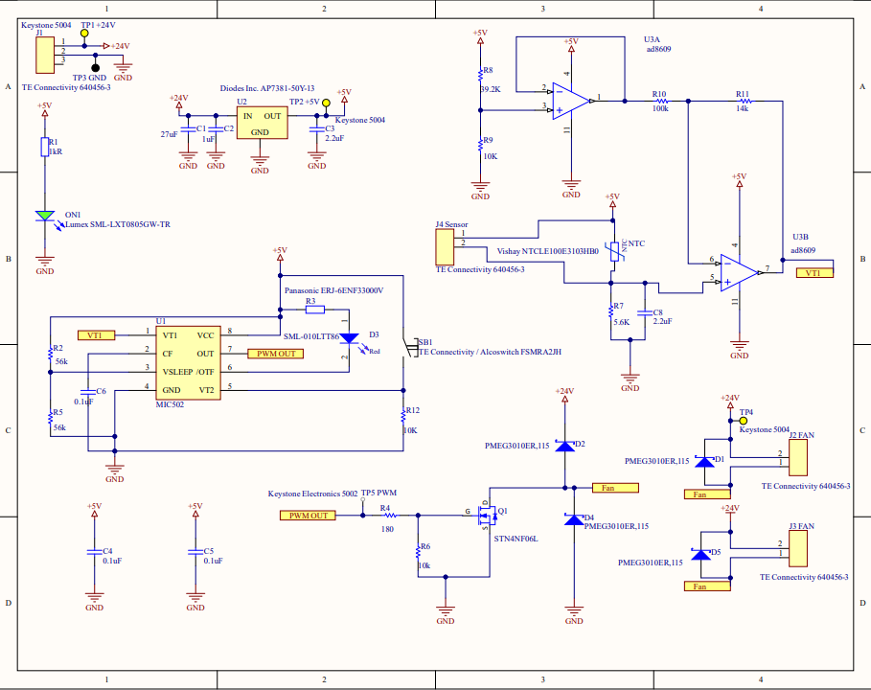
Figure 2. Uploaded fan-management schematic exported from CircuitMaker.

The transfer function is:
$$V_{T1}=\left(1 + \frac{R_{11}}{R_{10}}\right)V_{SENSE}-\left(\frac{R_{11}}{R_{10}}\right)V_{REF}$$So, this op-amp stage does two things at the same time: it slightly increases the slope of the thermistor voltage, and it shifts the output downward. This allows the VT1 voltage to be placed more accurately across the MIC502 shutdown, PWM, and overtemperature regions.
The most important design advantage of this gain/offset stage is flexibility. The MIC502 expects a specific voltage behavior at VT1, but different thermistors may produce very different raw sensing voltage ranges. Without U3A/U3B, the thermistor and divider resistor would have to be chosen very carefully so that the raw voltage naturally fits the MIC502 thresholds. That is restrictive.
With the gain/offset circuit, the design becomes adjustable. If a different NTC thermistor produces a raw voltage range that is too small, the designer can increase the U3B gain by changing the ratio of R11 to R10:
$$A_{v}=1+\frac{R_{11}}{R_{10}}$$If the entire voltage curve is shifted too high or too low, the designer can change the reference voltage generated by R8 and R9. Therefore, the circuit does not depend on one exact thermistor model. The thermistor, R7, R8/R9, and R10/R11 can be selected together to map the 0°C to 80°C temperature range into the desired MIC502 VT1 voltage range.

ATtiny25 System Operation
During normal operation, if the minimum fan-speed clamp is enabled, the firmware intentionally disables the MIC502-style shutdown/reset function. In this mode, VT1 is not allowed to shut the fan off even if the sensed voltage falls below the reset/shutdown threshold. Instead, the fan continues to run at a minimum duty cycle of approximately 25%. This guarantees continuous low-speed airflow and prevents the brushless DC fan from repeatedly turning fully off and restarting. Because fan startup typically requires higher current than steady low-speed rotation, avoiding repeated startup events reduces current demand, MOSFET power dissipation, supply stress, and mechanical wear. The output duty cycle is therefore calculated as:
$$D_{OUT}=max⁡(D_{VT1},25\%)$$
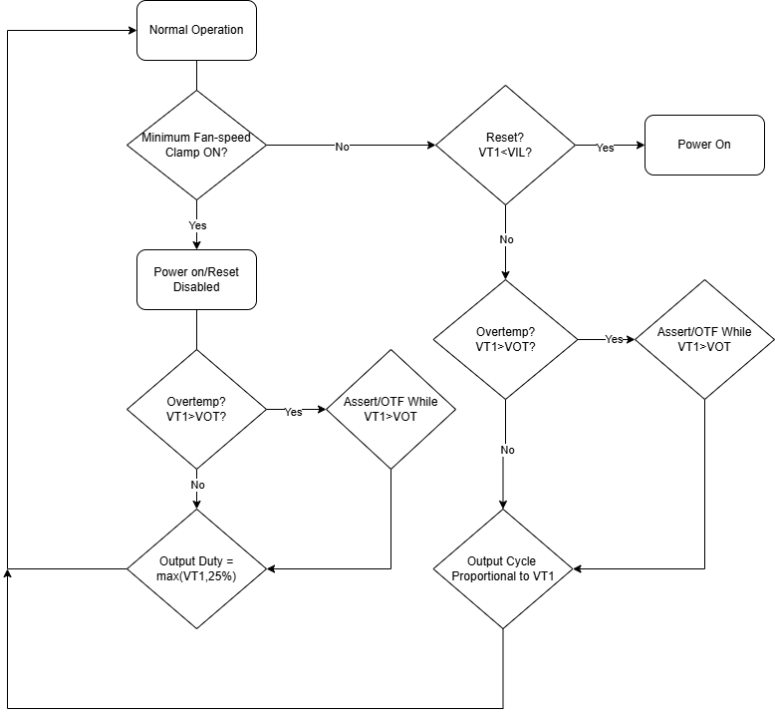
Figure 3. Normal System Behavior

This means that when VT1 represents a low-temperature condition, the fan remains at the minimum fan-speed setting instead of entering shutdown. Therefore, when VT1 represents a low-temperature condition, the fan continues to run at the minimum fan-speed setting instead of entering shutdown. This behavior is useful when the application requires continuous low-speed airflow and does not want the fan to stop completely.
For PWM generation, the ATtiny25 uses Timer/Counter0 in Fast PWM mode. The Timer0 control registers are TCCR0A and TCCR0B. In Fast PWM mode, the waveform generation bits WGM01 and WGM00 in TCCR0A, together with WGM02 in TCCR0B, select the PWM operating mode. The compare output mode bits, such as COM0A1:COM0A0, define how the OC0A output pin behaves during compare match. In non-inverting Fast PWM mode, the output is cleared on compare match and set again at BOTTOM. The duty cycle is controlled by writing an 8-bit value to OCR0A.
The PWM frequency is determined by the system clock, timer prescaler, and 8-bit timer period. In this project, using an 8 MHz clock and a 1024 prescaler gives:
$$f_{PWM}=\frac{8\text{ MHz}}{1024×256}≈30.5\text{ Hz}$$
This closely matches the MIC502’s typical 30 Hz PWM operation when CF = 0.1 µF. The ATtiny25 therefore recreates the MIC502 time base digitally instead of relying on an external timing capacitor. The Timer0 clock source and prescaler are selected using the CS02:CS00 bits in TCCR0B.
The overtemperature fault function remains active in this clamp-enabled mode. If the VT1 voltage rises above the overtemperature threshold $V_{OT}$, the ATtiny25 asserts the /OTF output low. The /OTF signal is used only as a fault indication; it does not disable the fan. Since $V_{OT}$is above the normal PWM control range, the fan output will already be driven at or near 100% duty cycle when this condition occurs.
When the minimum fan-speed clamp is disabled, the firmware behaves more like the original MIC502 shutdown/reset logic. In this mode, the VT1 shutdown threshold is monitored. If VT1 falls below $V_{IL}$, the firmware treats this as a reset or shutdown request and returns to the power-on/startup sequence. After restart, the startup timer forces the fan output fully on for the programmed startup interval before returning to normal PWM control.
If VT1 is above $V_{IL}$, the firmware remains in normal operation. The overtemperature threshold is then checked. If VT1 exceeds $V_{OT}$, /OTF is asserted low while the PWM output continues to follow the VT1-based duty calculation. If VT1 is below $V_{OT}$, /OTF is released and the output duty cycle is controlled proportionally by VT1.
The firmware also implements a startup behavior similar to the MIC502 startup timer. Every time the board is powered on, or every time the ATtiny25 exits the VT1-based power-off/reset condition after VT1 rises above the input-high threshold $V_{IH}$, the controller forces the PWM output to 100% duty cycle for 64 PWM cycles. This startup interval ensures that the brushless DC fan receives enough drive energy to reliably start from a stopped condition before the firmware returns to normal temperature-based PWM control. After the 64-cycle startup period finishes, the output duty cycle is again determined by the selected operating mode: either proportional VT1 control or the minimum fan-speed clamp behavior.

Parts List
Description | Designator
CAP CER 1000PF 50V 5% X7R 0603 | C1
CAP CER 1000PF 50V 5% X7R 0603 | C2
CAP CER 1000PF 50V 5% X7R 0603 | C3, C8
Capacitor; ECWU, SMD, Stacked Met PEN Film Cap, 100VDC, 0.10uF, 10%, 2416 T&R | C4, C5
CAP CER 1000PF 50V 5% X7R 0603 | C6
PMEG3010ER Series 30 V 1 A SMT MEGA Schottky Barrier Rectifier - SOD-123W | D1, D2, D4, D5
ROHM SML-010LTT86, SML-01 Series Red LED, 3020(1208), Rectangle Lens SMD package | D3
Header, Friction Lock; MTA-100; 3; 250 VAC; Polyester; Tin; Copper Alloy; Tin | J1, J2 FAN, J3 FAN, J4 Sensor
Thermistor NTC 10K Ohm 3% 2-Pin Radial 3977K -4.5 to -4 Bulk 2.54mm 0.100" | NTC
SML-LXT0805GW-TR Green LED, 565 nm 0805Diffused, Rectangle Lens SMD package | ON1
N-channel 60 V, 0.07 O, 4 A SOT-223 STripFET™ II Power MOSFET | Q1
Thick Film Resistors - SMD 0805 825ohms 1% Tol | R1
Thick Film Resistors - SMD 0805 62Kohms 1% Tol | R2, R5
Thick Film Resistors - SMD 0805 3.3kohms 1% Tol | R3
Thick Film Resistors - SMD 0805 976Kohms 1% Tolerance | R4
Thick Film Resistors - SMD 0805 976Kohms 1% Tolerance | R6
Thick Film Resistors - SMD 0402 13Kohms 5% Tol | R7
Thick Film Resistors - SMD 0402 13Kohms 5% Tol | R8
Thick Film Resistors - SMD 0402 13Kohms 5% Tol | R9, R12
Thick Film Resistors - SMD 0402 13Kohms 5% Tol | R10
Thick Film Resistors - SMD 0402 13Kohms 5% Tol | R11
Black Button Tactile Switch, SPST 50 mA@ 24 V dc 1.24mm | SB1
Keystone 5004 | TP1 +24V, TP2 +5V, TP4
KEYSTONE 5002 Series:- | TP5 PWM
FAN MANAGMENT IC | U1
LDO Regulator Pos 5V 0.15A 4-Pin(3+Tab) SOT-89 T/R | U2
Precision Micropower, Low Noise CMOS, Rail-to-Rail Input/Output Operational  Amplifiers | U3

Printed Circuit Board Layout

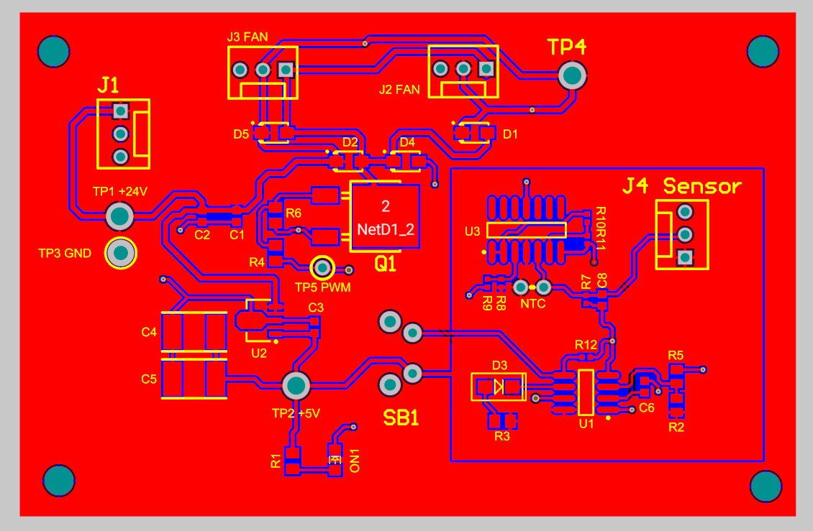
Figure B-2. Uploaded PCB

References
- Micrel, Inc., MIC502 Fan Management IC Datasheet, Revision 3.0, October 6, 2014.
- Atmel Corporation, ATtiny25/ATtiny45/ATtiny85 8-bit AVR Microcontroller Datasheet, Rev. 2586Q-AVR-08/2013.
- Micrel Applications Staff, Fan Health Monitoring and the MIC502, Application Note 34, October 1999.
- Analog Devices, AD8603/AD8607/AD8609 Precision Micropower, Low Noise CMOS Rail-to-Rail Input/Output Operational Amplifiers Data Sheet, Rev. D.
- Analog Devices, ADR01/ADR02/ADR03/ADR06 Precision Voltage References Data Sheet, Rev. S.

